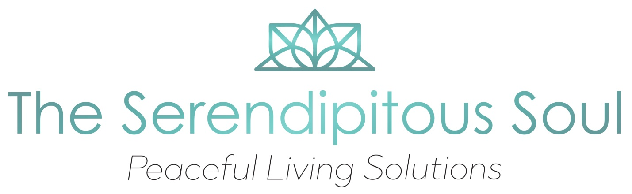
Upcoming Class and Workshop Offerings
More information as well as registration links for all classes can be found under the “Events” tab on my Facebook Business Page “The Serendipitous Soul” in my store https://squareup.com/market/theserendipitoussoul as well as under the “Classes” tab on my website www.theserendipitoussoul.com
Hope to see you soon! My best, always – Jennifer Raybaud
Evening classes held at 7 PM at “The Serendipitous Soul” at 27739 Jefferson Ave. – St. Clair Shores – 90-Minute classes are $25 unless otherwise noted. _____________________________________________________
Mon. 3/2 – Return to Your Heart – A Freewill Donation-Based Workshop – 6:30 PM - In this workshop we'll explore what it means to return to your heart, choose your feelings, and create a life with intention. This is a free-will donation-based workshop so give what you wish. We'll be mixing some written exercises and group discussion to round out the hour. 60-Minutes (Registration for this offering via our Facebook Event page)
Tues. 3/3 – Beginning Meditation – Seeking the Stillness – at The SheHive - Have you heard of all the wonderful benefits of meditation but think you can't meditate? Anyone can learn and this class will help you find simple and practical ways to start a meditation practice. 90-Minutes
Weds. 3/4 – Lucky 7 – 7 Ways to Live Your Best Life Today - We’ll enjoy some relaxation via some "happiness increasing" practices during this workshop because feeling relaxed is a GREAT way to add happiness to your life but we’ll also be learning about the seven things you can do today to live in that "feelin' good" heart and mind space more often! Handouts will be provided with the practices so you can easily do them at home or at the office! 90-Minutes
Thurs. 3/5 – Exercising Your Intuition - The Power of Words - 6:30 PM - The inspiration for this workshop came from "Kindred Spirits" and the women's circle I did earlier this month. Our group participated in an exercise that when they began, felt very odd but as we went on, they could see the power the exercise brought in asking them to fire-up their intuition and the beautiful thing was, all the other participants in the circle were asked to listen to and bring theirs to the table as well, in support of the other participants and boy, did they deliver! I'm now taking that one exercise and making a workshop out of it since the women in our circle even said, they would have loved to have done more if time hadn't run out. So, join me for 2-hours of connection, laughs, some AH-HA's and maybe even a few tears as we fire-up our intuition and give it a little exercise while we assist and inform ourselves and others. 120-Minutes
Tues. 3/10 – Can You Hear Me Now? – Developing More Powerful Connections – At the SheHive - Connections with both ourselves, as well as others, aren't just nice things to have, we are hard-wired for human connection but in a day and age where most people get their connections through a cable, we'll talk about how you can intentionally cultivate more intimate, meaningful, mindful, high-quality connections with yourself as well as those who enter into your day to day life. 90-Minutes
Weds. 3/11 – Compose Yourself – Music, Mindfulness and More - Join us for this class which will include a fabulous Mindfulness lesson in how to REALLY listen to music, followed by (are you ready for this?) a heavy-metal mediation before we take it down a notch! I love teaching this class. Lightbulbs and "Ah Ha" moments everywhere! If you love music, you'll love it even more after attending this interactive class. We listen, we discuss, we learn. Beautiful! 90-Minutes
Thurs. 3/12 – The Five Levels of Attachment – Removing Limits – Living Lighter – SOLD OUT in February so it’s BACK - We have all unwittingly made agreements about how we choose to live our lives and what we believe our personal truths are. But what we may not realize is that each one of these agreements represents an attachment, a limiting filter on who we think we are, and what the future could hold. This class will provide the understanding and guidance on how to go about re-evaluating, reducing or even severing attachments that no longer serve you. 90-Minutes
Sat. 3/14– Kindred Spirits – A Women’s Circle - 10AM - Welcome to a totally new kind of offering at "The Serendipitous Soul" Each month we'll begin with some social time and refreshments, then we'll "deep dive" into a specific self-awareness building topic, we'll enjoy an exercise to help us connect to ourselves more often and with more ease. Finally, we'll be participating in a hands-on activity every month as well. Connections of the highest form and all in 120-minutes!
Mon. 3/16 – Forward Focused - Group Life Coaching - I get asked all the time "what's a life coach do?" Here's the perfect way to get a taste while connecting and learning from others. Join me for this opportunity to not only have a specific concern of yours addressed by a coach but enjoy gaining "pearls of wisdom" from your fellow participants and their interactions with the coach as well. Each participant will have 10 minutes to bring a situation, problem, life area, etc. they would like some help and potential guidance on to the group. The coach will then work with you and your concern in the group so you and the other participants can potentially benefit from the exchange. We're keeping this event very affordable so you get a feel of life coaching with a very small investment. $10 90-Minutes
Tues. 3/17 – The Four Agreements – Easier Said Than Done – at The SheHive - My most popular class for a reason! This small book, containing four simple concepts can change your life. Although the concepts are easy to understand, implementing them requires some thought and skill. This class will have us learning how to put these concepts "into play" so we have new ways of thinking, leading to new ways of peace in our everyday life. You don't have to have read the book to enjoy the class. 90-Minutes
Weds. 3/18 – Emotional Intelligence (EQ) – A Key to Happiness and Success - Emotional intelligence is something that affects all of us in each interaction that we have with others. It is key to the quality of both our personal and business relationships. In this class, we’ll address what “emotional intelligence” is, we’ll learn about “the five keys” and the ability to understand and effectively manage one’s emotions as well as the ability to “read” others a bit better. 90-Minutes
Thurs. 3/19 – Flower Power – A Floral Remedy Make & Take – 6:30 PM – at Kitty Deluxe - A NEW "hands-on" workshop! In this workshop, we'll begin by learning all about floral remedies, how they began, what they can offer us and how to best incorporate them into your daily life. Then through various modalities, the second half of our workshop will have us working on finding out exactly what mixture or "bouquet" would serve you best and here's the fun part...you'll then blend your custom remedy as part of the workshop and take the 100+ day supply home with you! I hope you can join us for this fun and unique offering! 120-Minutes $40 includes materials
Tues. 3/24 – The Need to Please – Learning to Honor Yourself and Others – at The SheHive - Are you a person who feels compelled to please other people often to your own detriment? Don't want to live like that anymore? Then join us for this class filled with mind-opening ideas and tools to help you navigate a healthier way of living. Liberation from a lifetime of feeling the need to go out of your way begins here. 90-Minutes
Weds. 3/25 – Smart Thinking – Less Overthinking – More Peace - Welcome to a newer class, designed to help you learn "critical thinking" so you can stop overthinking so much. What is critical thinking? It's the ability to think clearly and rationally, understanding the logical connection between ideas by leveraging a simple process we will learn and "test drive" during this class. Let's have some fun learning how to "think" more efficiently and effectively! 90-Minutes
Thurs. 3/26 – 5-4-3-2-1- Launch Your Life! - Procrastinate a little? I had the pleasure of seeing and interacting with massively popular author Mel Robbins back in 2017. She's one incredible woman with one totally relatable story of transformation. Her book "The 5 Second Rule" is an undeniable game-changer and this class will share how to get yourself "unstuck" and out of procrastination so you can "transform your life, work, and confidence with everyday courage." "If you can count, you can have everything you want." - Mel Robbins 90-Minutes
Sun. 3/29 – “Lucky Me” – A 2- Hour Relaxing Mini-Retreat – at Hippie Yoga – 4 PM - Join us for March's mini-retreat complete with warmth, candlelight, meditations, gentle stretching, beautiful readings and more, all while you relax and reset yourself for the week ahead! Register for this event at myhippieyoga.com $25
Tues. 3/31 – Thanks for Everything – More Fulfillment in the Modern World – This NEW class will have us deep-diving into gratitude. From the science of it to practicing it in ways you may have never dreamed of. You'll understand the power of being more intentional when it comes to gratitude and its roll in living a more fulfilled life especially during these modern times. 90-Minutes
___________________________________________
" If you are looking to step up your self-help game or you are on a path to a healthier, better you I highly recommend attending some classes!" - Barbara M.

Love a lot of what you see? Then consider joining our VIP Client Program. 6 Classes of your choosing ($25 or $30 offerings) over 4 months for $150! Enjoy a few other perks as well like a FREE 2-hour relaxing mini-retreat during your active program status – a $25 value and more!
You’ll find all the details and the ability to join in our store:
https://squareup.com/market/theserendipitoussoul
Looking for more direction and clarity in your life so you can live it with more intention? Then ask me about both my private coaching as well as my wonderful programs like “The Desire Map”, “Free & Clear” and “Firestarter’s.” We can schedule a quick “discovery call” to see if what you’re looking for is a match with what I provide to my private clients. I would LOVE to chat with you!
theserendipitoussoul@gmail.com
